3. a) define F-distribution with degrees of freedom $n_{1} and n2 and point out its uses?$
Slv:
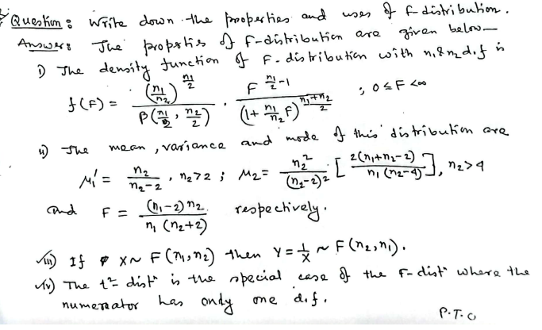
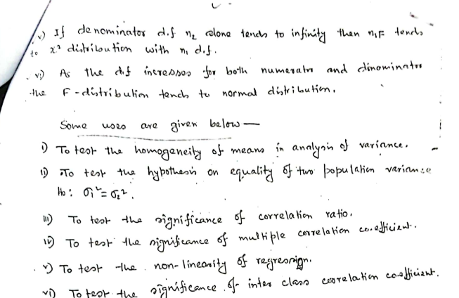
b) discuss the relationship among F, t and $χ^{2}$ distribution.
The F, t, and χ2 distributions are all continuous probability distributions that are used in statistical inference. They are all related to the normal distribution, but they have different shapes and are used for different purposes.
The F distribution is used to compare the variances of two or more populations. It is defined as the ratio of the variances of two independent chi-squared distributions. The t distribution is used to compare the means of two populations when the population variances are unknown. It is defined as the ratio of the sample mean to the standard deviation of the sample, divided by the square root of the sample size. The χ2 distribution is used to test the goodness of fit of a theoretical distribution to a set of data. It is defined as the sum of the squared deviations of the data points from the mean of the distribution.
The F distribution is related to the χ2 distribution in the following way: the F distribution with degrees of freedom m and n is the same as the ratio of two χ2 distributions with degrees of freedom m and n, respectively. The t distribution is related to the F distribution in the following way: the t distribution with degrees of freedom n is the same as the square root of the F distribution with degrees of freedom 1 and n.
The F, t, and χ2 distributions are all important tools in statistical inference. They are used to test hypotheses about the population mean, variance, and distribution. They are also used to compare the means and variances of two or more populations.

